**Fluorescence-based Analysis**

**Materials：**

• Fluorescence plate reader (e.g. Tecan Genios)

• Black, optical-bottom 384-well plate (e.g. Nunc)

• Phosphate-buffered saline (1x PBS)

• Recombinant eGFP (Cell Biolab, # STA-201)

**Procedure:**

**(A) Qualitative (visual) Analysis**

Compare the intensity of (green) color in your myTXTL control reaction to the following standard eGFP color strip (Figure 1) to assess deGFP produced in your tube.

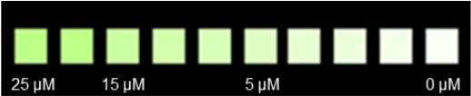

*Figure 1. Color strip for the qualitative analysis of deGFP production*

**(B) Quantitative Analysis**

**1. Prepare an eGFP standard curve (0-5 µM)**

• Thaw and keep the recombinant eGFP standard (Cell Biolabs, # STA-201) on ice. Determine the molar concentration of your protein solution.

• Prepare an eGFP stock solution of 5 µM in PBS (V = 70 µL) in a 1.5 mL reaction tube. Example: If your eGFP standard has a concentration of 30 µM, transfer 11.7 µL of the 30 µM eGFP protein solution to 58.3 µL PBS, mix thoroughly and collect mixture on the tube bottom by a short centrifugation step.

• Prepare a 2-fold dilution series of eGFP in the concentration range of 0-5 µM in 1.5 mL reaction tubes (5, 2.5, 1.25, 0.63 and 0.31 µM). Example: To prepare a 2.5 µM eGFP solution, transfer 35 µL of the 5 µM eGFP solution to 35µL PBS and mix thoroughly. Then take 35 µL of the 2.5 µM eGFP solution to prepare the next dilution step. Proceed to 0.31µM eGFP (five dilution steps).

• For each dilution, transfer 10 µL/well in triplicate into a black, optical-bottom 384-well plate. Also include a Blank measurement in triplicate using PBS only.

**2. Dilute the myTXTL control reaction**

• Prepare a 10-fold dilution of the centrifuged myTXTL control reaction in PBS. In a 1.5 mL reaction tube, add 4 µL myTXTL control reaction to 36 µL PBS, mix thoroughly and collect mixture on the tube bottom by a short centrifugation step.

• Transfer 10 µL/well of this diluted sample in triplicate to the same 384-well plate as the eGFP standard dilution series (see above).

**3. Perform fluorescence measurement using a plate reader**

• Before the fluorescence measurement, carefully tap or briefly spin down the 384-well plate to remove any air bubbles and to equally distribute each sample in the well.

• Fluorescence reader setting: Choose an excitation and emission wavelength appropriate for

eGFP measurement (e.g. excitation: 488 nm, emission: 535 nm).

**4. Calculate the deGFP concentration using a calibration curve (linear regression)**

• Subtract the fluorescence values of the Blank (PBS only) from that of each standard protein

and myTXTL control reaction.

• Plot the Blank subtracted fluorescence values of the eGFP standard (Y-axis) against their respective protein concentration (X-axis) and fit the curve to the linear regression formula

(y = m*x) to determine the deGFP concentration in the myTXTL control reaction (Figure 2).

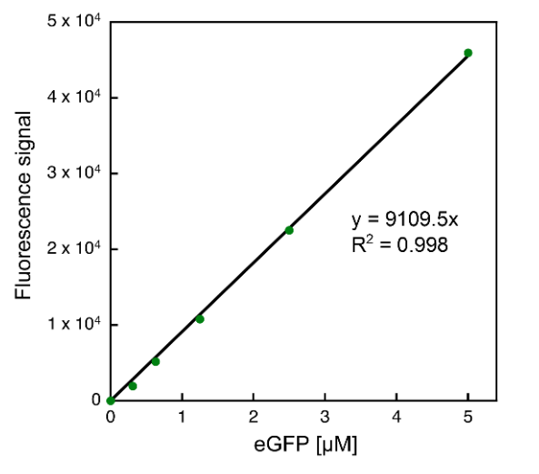

*Figure 2. eGFP standard curve to evaluate protein production efficiency in myTXTL*

**Reference:**

1. myTXTL Cell-Free Expression Handbook(http://www.arborbiosci.com/)